The Most Important Local SEO Decisions You Better Get Right

Top Tactics To Improve Your Local Search Rank
- Google Local Settings
- Title Tags
- Which Directories to Use
- Getting Google +1’s and Reviews
- Location, Location, Location (NAP on page)
- Google Map
- Schema Markup

When I started my business a while back, Google was still the search engine of choice, but utilizing PPC ads and some dated SEO tactics were en vogue at the time to get on Google’s results page #1. Today, competition as we all know is super high in most major national and local markets, and there exists recent Local SEO tactics which businesses must get right or their search rank won’t be as strong as it can.

In this post, I am sharing some current top Local SEO tactics that businesses should incorporate to help increase their chances of getting found in their local market, increase their online traffic and generate more leads. In my experience, utilizing these Local SEO tactics for my clients has helped them capitalize immensely by attaining page #1 Google rank for their top search terms and 3x – 5x growth in their organic search traffic. They work.

Quick Chart before we dive in.
Hmm, does page rank still really matter???

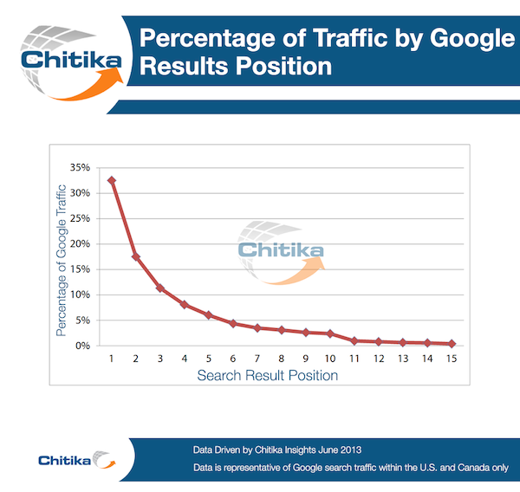

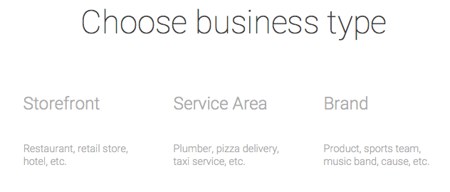

1. Google Local Set Up-
Setting your business up with Google Local Business tools is critical for your online business success. If you are new to the online marketing world & just purchased your domain or managing a global Fortune 500, it’s paramount that you learn what Google offers you and that you take advantage of it. So be sure to check out www.google.com/business. Here you can register your business with Google and you will need to select what business type yours is. The three business types in the image above are self explanatory and Google does provide insight for each, but just in case you have any confusion, here’s a quick synopsis.

a) Storefront- if you have a physical presence where you serve clients (eg. Pizza shop, restaurant, hotel, retail store, dentist.)

b) Service Area- if you have a business that services a certain area and you visit your customers to serve them. (eg. Painter, plumber, taxi service.)

c) Brand- if you have a brand that operates in a certain area locally, regionally or nationally. (eg. Sports team, charity, food & beverage.)
For more on Google tools be sure to view:
https://www.google.com/webmasters

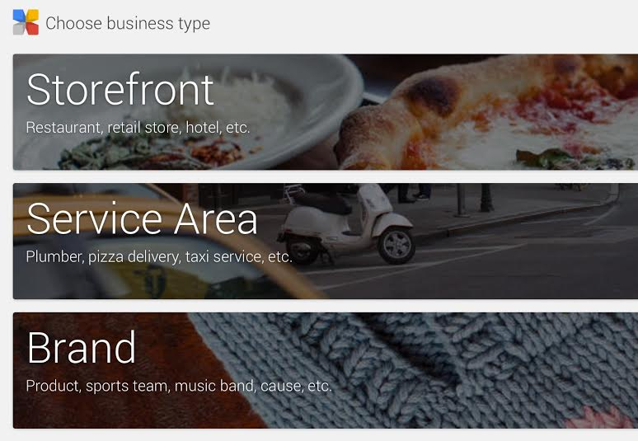

The next important decision that carries a lot of weight into your local search results is selecting the right business Category for your business or service. As you can see below, you want to make sure you choose the exact one that fits your business and which your customers will inevitably type into a Google search. Get it right.

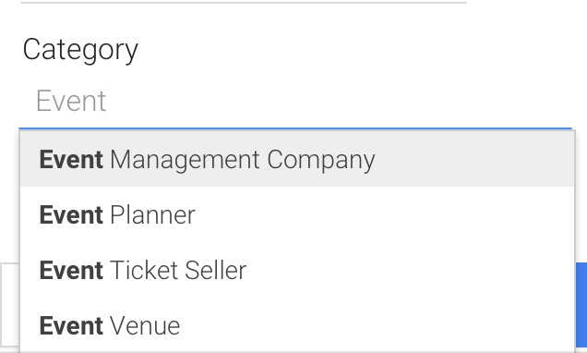

2. TITLE TAGS
The single most important piece of content and code on your page are the Title Tags. Please note we said page. Remember, Google does not rank websites; they rank pages. Hence, for Local SEO make sure that you utilize your hometown or city where your business services its customers since after all, that’s really the most important thing that will help connect you with customers on Google and all major search engines. The next few words you should use are ones that describe what you do and should be your top keywords. Then it’s common to place your brand name last. An example of this is below: “Boston SEO & Search Marketing Services Company | Auctus Marketing” is the title tag. For some insight on how to choose the most optimal keywords for your business click here.

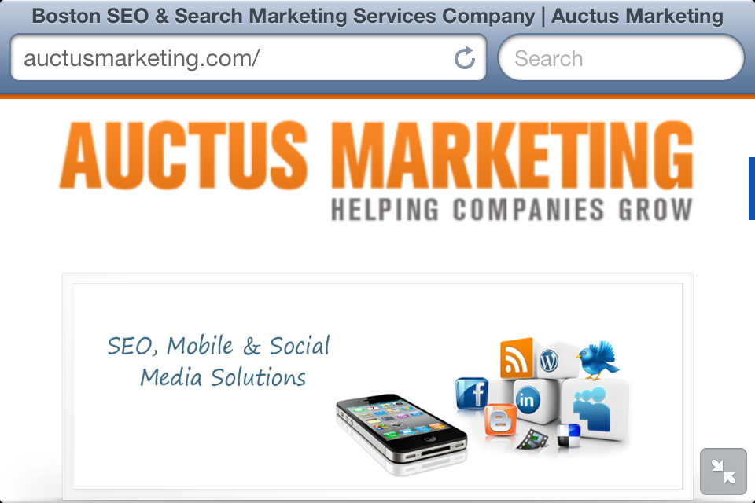

The next important piece of the puzzle for your on-site SEO is your Meta Description, which provides your customers & online searchers with a description of your product or service. This Description is the text that appears under your title tag in the search engine results page or commonly referred to as SERP. Below is an example: The blue copy is the Title Tag. The Black copy is the Meta Description. It will help to improve your search rank, if you include your top keywords in this.

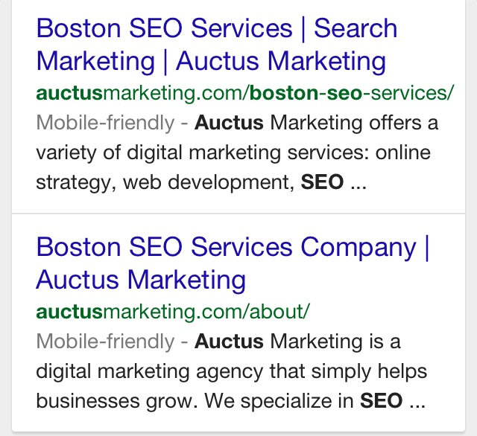

3. Directories To Use-
In the competitive online search market, it’s vital that you not only get your Google Local info correct, but you also want to be listed in certain online quality directories that are commonly used in your industry. This will help to increase your local search rank on Google, but will also give you another online destination where you can be found. A very helpful service to get you started with this is Moz Local. Also, we highly recommend that you register your site with Yahoo & Bing. Yahoo’s listing cost money, but is worth it. For more on Yahoo, https://smallbusiness.yahoo.com/local-listings

https://moz.com/local

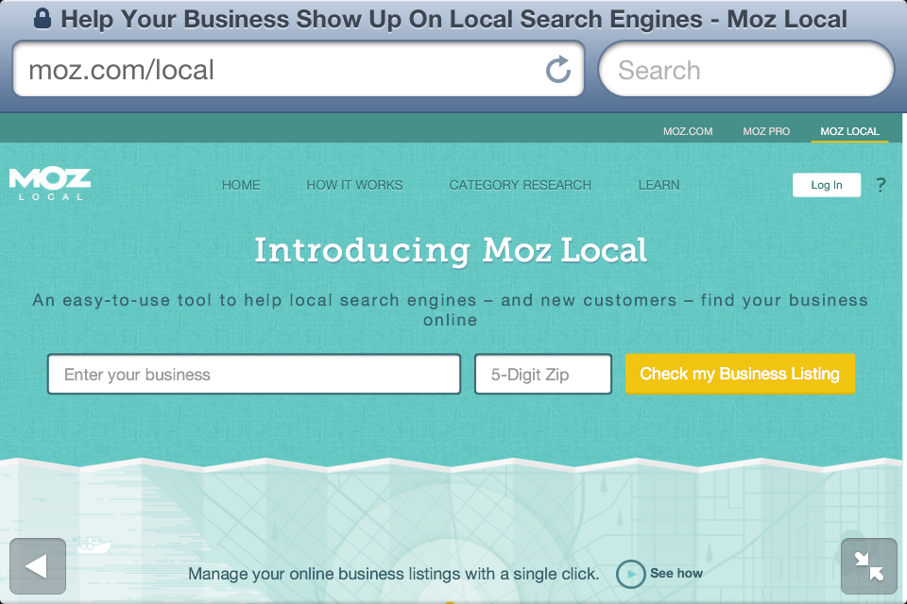

For a more comprehensive list of directories, see below-
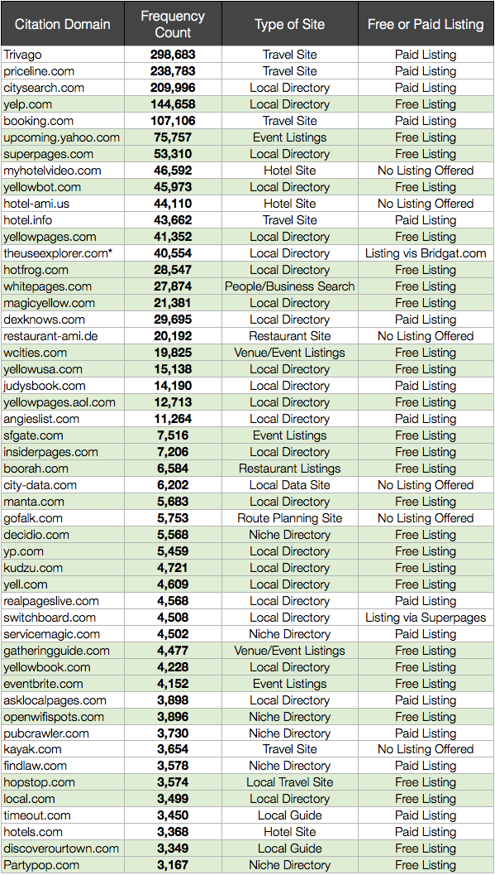*(please note that http://www.houzz.com/ is not listed.)
To shed some light on the importance of selecting quality directories for your business & site, here is some recent 2015 data on the subject from BrightLocal. We hope this helps your selection process.

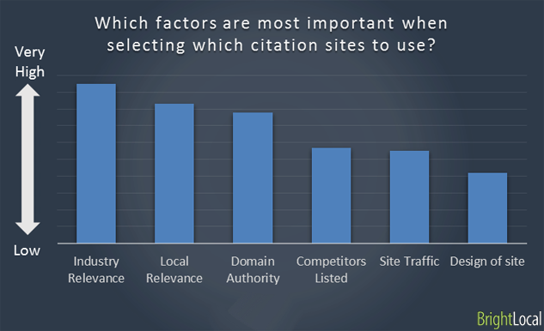

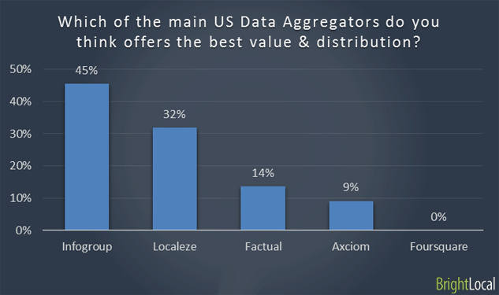

4. The Real Value of +1 & Reviews
In case you don’t know, social signals especially +1’s from Google and customer reviews on your Google Local page carry a fair amount of weight in determining your organic search rank. So be sure to post regular quality content on your Google Local business page and build up your connections in this social channel. Like most of us that grew up using Facebook (or in my case MySpace), you want to use a lot of the same underlying tactics that you used on Facebook. You also want to make sure you attain reviews on your Google Local business page from customers because once again this is an important factor in determining your local rank versus your competition. A nice way to do this is to send your Google Local page to a customer, request a review and offer them a discount or free promo. Do this in a nice, genuine and sincere manner and see what happens. If you want, you can copy & paste this email-

Hey _______

Hope all is well and we want you to know that we greatly appreciate your support! We simply love being part of this great local (insert town/city) community. To help us better serve you, we would appreciate a quick review on our Google Local Business page, (insert link here) and we hope to see you soon.

Have a great day!

Your Name

*if you want to include a promo code or discount, go for it. As a token of our appreciation of you, please use this coupon next time you are in the store. Thx!

5. Location- NAP
This one is very straightforward and easy for you to knock out and get right. Make sure that your NAP (Name, Address, and Phone number) is listed on your homepage. If you have just one location, then have this NAP on all of your pages, which makes it easy for your customers to attain this info. Be sure to include this on your mobile page too. If you have multiple locations, then just make sure that you have a page for each and each NAP is very clear. We recommend that you place this info on your page’s footer, but also make it available above the viewer’s fold too, so they don’t have to scroll down.

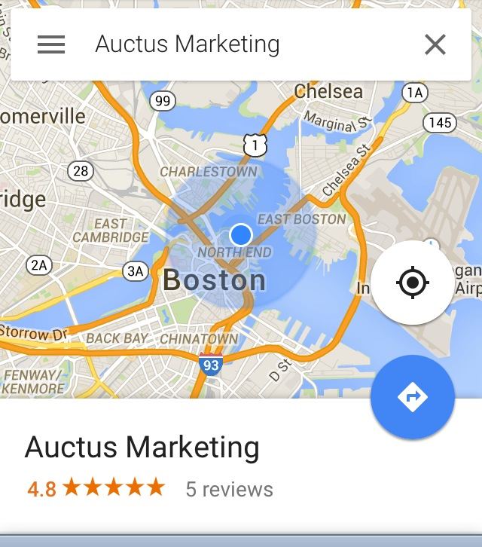

6. Google Map
This step is more of a reminder of how important it is that you add your business to Google Local, which is Step #1 listed above. Yes, we are simply stressing the importance of this step again and that you fill out all of the necessary information on your page.
- First see if you business is already listed on Google.
- If not, add your address & info.
- Verification- before they list you, they will need to verify your address.
- Then you need to complete your business profile.
- Grow your page by connecting with others.
- Check out Step #4 above again.

7. Schema Markup
Google has made reference that they want webmasters to use Schema Markup for their Name Address & Phone. Tip- not a lot of site owners are using it and Google prefers this code style.
You can use their Markup Tool in GWT Google Webmaster Tools or here’s the code that you can adapt to your own website:
<div itemscope itemtype="http://schema.org/LocalBusiness"> <p itemprop="name">COMPANY NAME</p> <p
itemprop="address" itemscope itemtype="http://schema.org/PostalAddress"> <p itemprop="streetAddress">ADDRESS LINE 1</p> <p itemprop="addressLocality">CITY</p>, <p
itemprop="addressRegion">REGION</p> <p itemprop="postalCode">POSTCODE/ZIP</p. <p
itemprop="telephone">PHONE NUMBER</p> <meta itemprop="latitude" content="LATITUDE" /> <meta itemprop="longitude" content="LONGITUDE" /> </div>
All you need to do is change the text in bold to your own details — simple.

Example of Schema Markup Code-
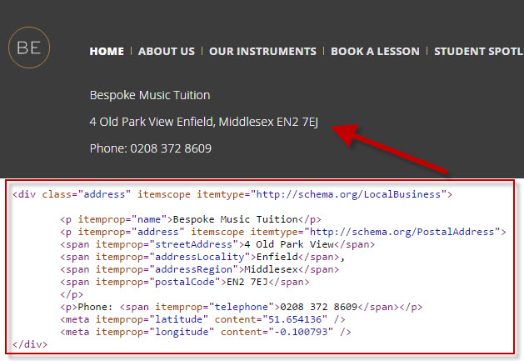

We hope you have found this list helpful and we would appreciate any feedback. Also, please share this with others if you find it very useful. info@auctusmarketing.com

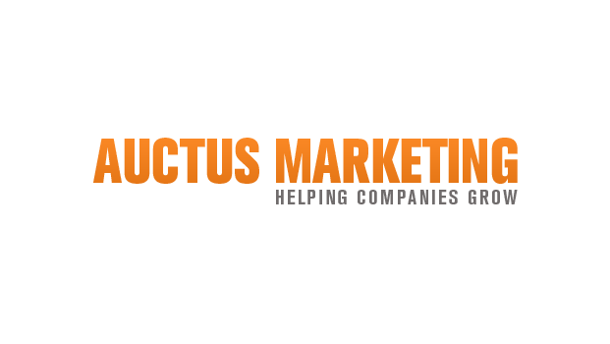

www.auctusmarketing.com
Boston, MA | 617.990.7745
info@auctusmarketing.com

